**Stage 5 - “Are Those Forward Falling?”**

**RULES:** USPSA Competition Rules, Latest Edition **COURSE DESIGNER:** Ike Starnes

|  |  |
| --- | --- |
| **START POSITION:** Both feet inside the shooting area.  **Handgun**: Loaded and holstered, wrists above respective shoulders.  **PCC**: Loaded, stock on belt, strong hand wrist above shoulder. | |
| **STAGE PROCEDURE**  See written stage briefing. | **SCORING**  **SCORING:** Comstock 19 rounds.  **TARGETS:** 7 cardboard targets, 5 steel targets.  **SCORED HITS:** 2 Best hits per carboard will be scored, steel must fall to score.  **START-STOP:**  Audible - Last shot  **PENALTIES:** Per USPSA Competition Rules |

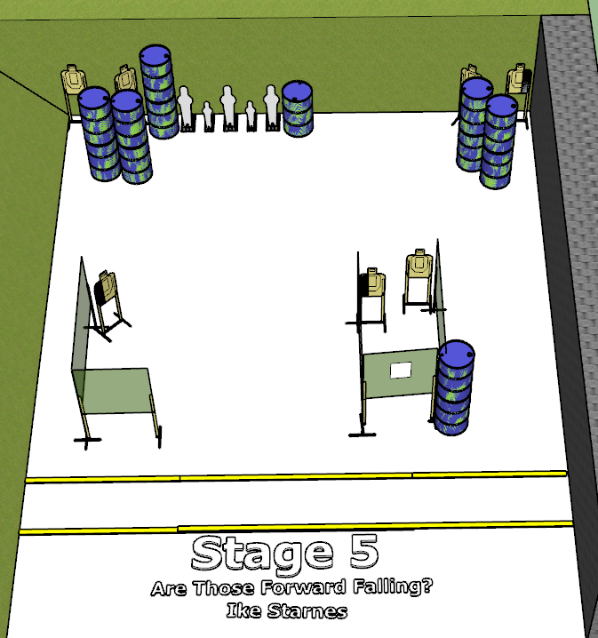

**Written Stage Briefing:**

**Stage 5 - “Are Those Forward Falling?”–** is a 19-round, 95 point, Comstock Medium Course. There are 7 cardboard targets and 5 steel targets. The best 2 hits per cardboard target will be scored. The steel must fall to score.

**Start position** Both feet inside the shooting area.

**Handgun**: Loaded and holstered, wrists above respective shoulders.

**PCC**: Loaded, stock on belt, strong hand wrist above shoulder.

On the audible start signal, engage targets from within the shooting area.

**Setup Notes:**

4 Single Wall Stands

3 Double Wall Stands

3 Full Walls

1 Half Wall

1 Half Wall with Port

8 Target Stands / 16 Target Sticks

2 Mini Poppers

3 Poppers

5 Steel Target Bases

13+ barrels